**Shifting Economic Mass Towards Emerging Economies Shown in Global Freight Data**

**The latest update of global freight data collected by the International Transport Forum at the OECD through September 2013 reinforces the observation of a shift of economic mass to emerging economies:**

* **USA and EU27 exports increase strongly and imports decline markedly, reflecting weak domestic demand and stronger performance of emerging economies;**
* **EU external trade by air, considered as a lead indicator, rebounds above pre-crisis peak, indicating a potential improvement of the economic outlook;**
* **Road and rail freight data continue to point out weak domestic demand especially in the EU area.**

The overall picture for global freight shows no major improvement since the previous brief. Total external trade by sea (in tonnes) continues to stagnate below pre-crisis levels in the United States (-8%) and EU27 (-3%). Exports and imports transported by sea display increasingly diverging trends. Total exports remain above pre-crisis levels (EU27 28%; United States 19%) while imports decline further (EU27 -15%; United States -24%). This reinforces the observation of a rebalancing trade and transport flows, mainly driven by weak performance of the advanced economies (Figures 1-5).

* **A rebalancing of trade and transport flows**
* **EU trade by air rebounds**

Air freight, considered a lead indicator, suggests continued uncertainty. United States external trade by air stagnates below pre-crisis levels. However, EU trade by air rebounds above the pre-crisis peak (+3%), indicating a potential improvement of the economic outlook (Figures 1-5).

Exports to BRICS, and more specifically to China and India, have been the locomotive of European and North American growth since the crisis of 2008. However, trade shows signs of slowing down. External trade by sea from India to EU27 and the United States has declined during the last two quarters while trade by air is stagnating both in India and China (Figures 6-7).

* **Surface freight slowing down**

Freight transported by road and rail in the EU stagnate at -13% and -8% below pre-crisis peak respectively, reflecting continuous weak domestic demand. Rail freight volumes in the United States and the Russian Federation reached pre-crisis peaks earlier but show signs of slowing down. Rail freight in China shows also signs of slowing down after a period of strong growth (Figures 8-9).

Figure 1. **External trade, percentage change from June 2008**

(Tonnes, monthly trend, seasonally adjusted)



Figure 2. **EU external trade by sea, percentage change from June 2008**

(Tonnes, monthly trend, seasonally adjusted)



Figure 3. **EU external trade by air, percentage change from June 2008**

(Tonnes, monthly trend, seasonally adjusted)



Figure 4. **USA external trade by sea, percentage change from June 2008**

(Tonnes, monthly trend, seasonally adjusted)



Figure 5. **USA external trade by air, percentage change from June 2008**

(Tonnes, monthly trend, seasonally adjusted)



Figure 6. **BRICS external trade by sea with EU27 and United States,**

**June 2008=100**

(Tonnes, monthly trend, seasonally adjusted)



Figure 7. **BRICS external trade by air with EU27 and United States,**

**June 2008=100**

(Tonnes, monthly trend, seasonally adjusted)



Figure 8. **National and international rail freight**

(Million tonne-km, trend, seasonally adjusted)

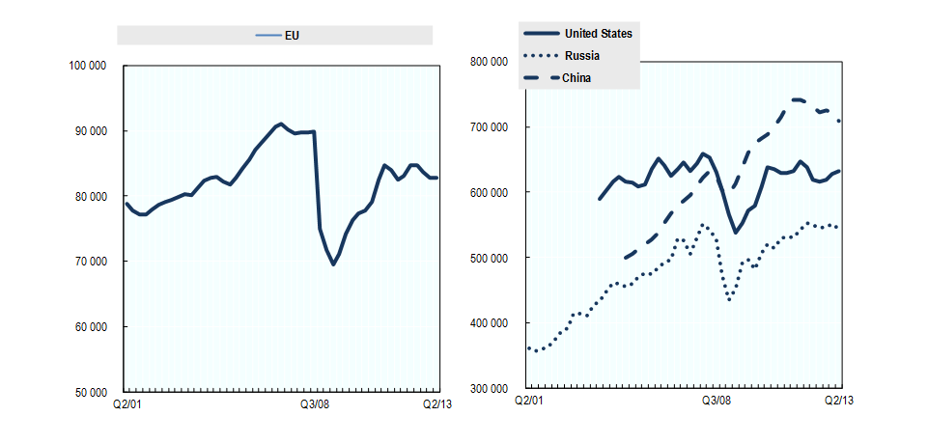

**Note:** China data is sourced from National Bureau of Statistics of China. EU rail freight data includes: Austria, Bulgaria, Croatia, Czech Republic, Denmark, Estonia, Finland, France, Germany, Hungary, Ireland, Latvia, Lithuania, Luxembourg, Poland, Portugal, Slovakia, Slovenia, Spain, Sweden, United Kingdom. These cover around 90% of total rail freight in the EU.

Figure 9. **National and international road freight in the EU**

(Million tonne-km, trend, seasonally adjusted)



**Note:** Data on road freight in the EU area include Bulgaria, Croatia, Czech Republic, Denmark, Estonia, Finland, France, Germany, Hungary, Latvia, Lithuania, Poland, Slovakia, Spain, Sweden. These cover around 75% of total road freight in the EU.

|  |
| --- |
| **Methodological note**  The International Transport Forum Statistics Brief on Global Trade and Transport presents the latest global freight transport trends based on the Global Trade and Transport Database and the ITF Quarterly Transport Statistics. These data are collected by the Secretariat through a questionnaire and from external sources, including Eurostat, US Census and Japan Customs. National data are seasonally adjusted by the International Transport Forum Secretariat for analytical purposes.  Short-term data is normally compiled to allow timely identification of changes in any indicator and especially to identify possible turning points. However, monthly or quarterly transport statistics are often characterised by seasonal patterns. Seasonal adjustment filters out usual seasonal fluctuations that recur with similar intensity in the same season every year. Trend, in turn, excludes also other irregular factors (such as strikes and impact of weather) from a time series. A time series from which the seasonal variations have been eliminated basically allows for the comparison of data between two quarters for which seasonal patterns are different, also helping to identify turning points and the underlying direction of the change.  Seasonal adjustment is carried out with the Demetra program using the TRAMO/SEATS adjustment method. Seasonally adjusted estimates may differ from those produced by national authorities due to differences in the adjustment methodology.  For more detailed description of methodology, [click here](http://www.internationaltransportforum.org/statistics/Method.pdf). |

If you would like to receive further issues of the Statistics Brief or more information, please contact: Mr Edouard Chong ([edouard.chong@oecd.org](mailto:edouard.chong@oecd.org)) or Mr Jari Kauppila ([jari.kauppila@oecd.org](mailto:jari.kauppila@oecd.org)).

For additional information on our transport statistics, go to [www.internationaltransportforum.org/statistics/shortterm/index.html](http://www.internationaltransportforum.org/statistics/shortterm/index.html).